Problem 1: Write a C++ program to delete an array element using its index number.

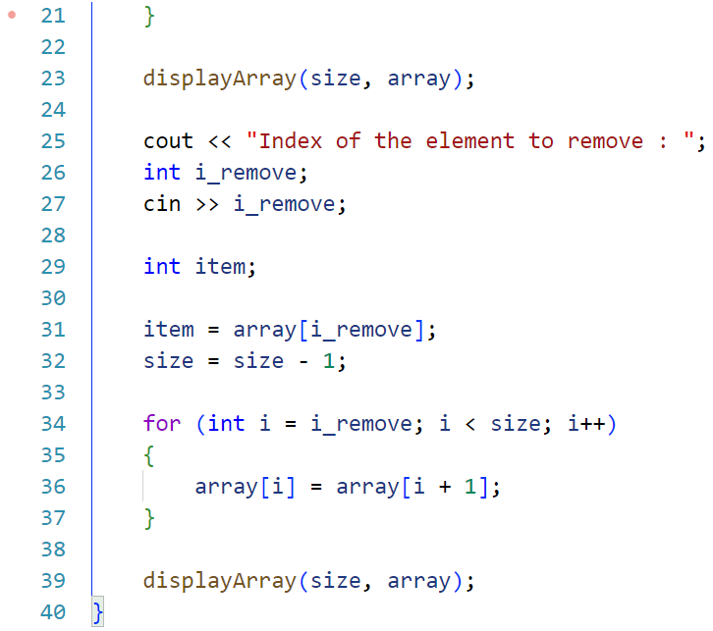Code:

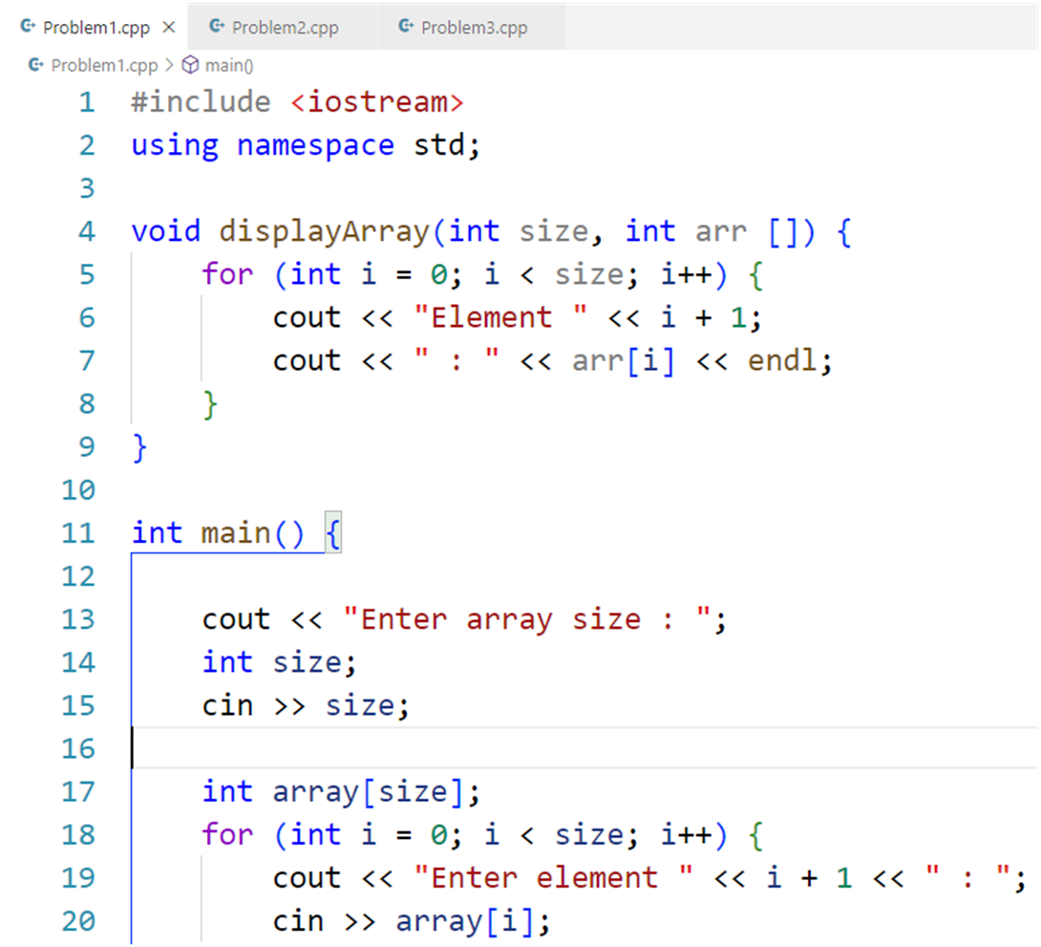

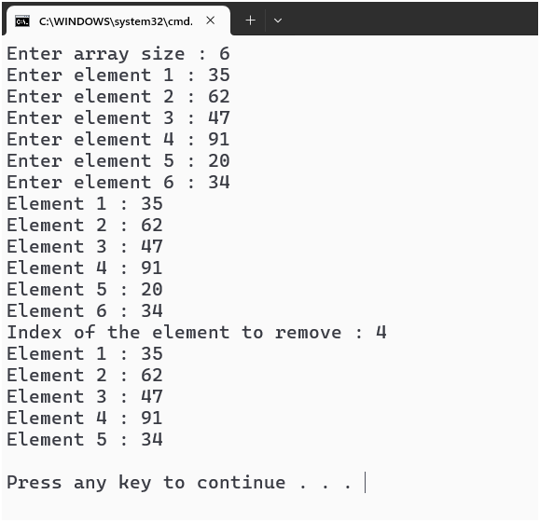Output:

Problem 2: Write a C++ program to delete an array element by its value using linear search.

Code:

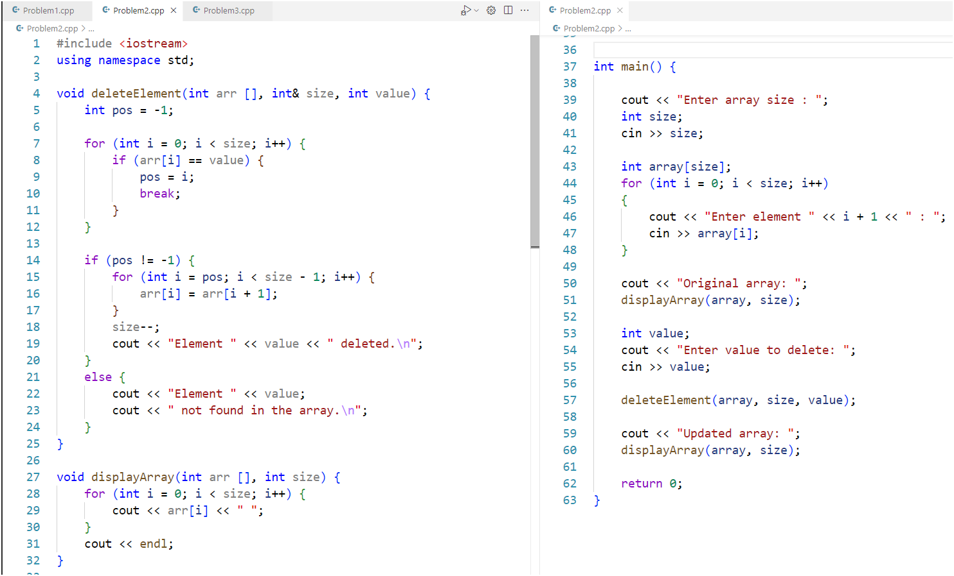

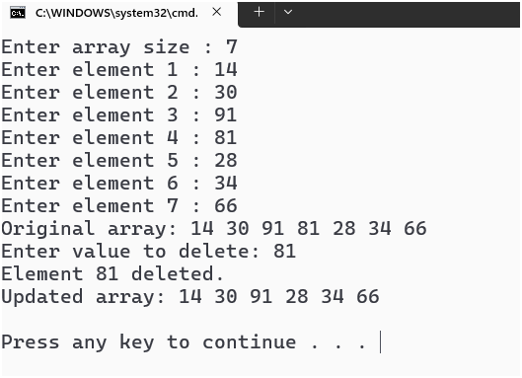Output:

Problem 3: Write a C++ program to perform a binary search on an ascending sorted array.

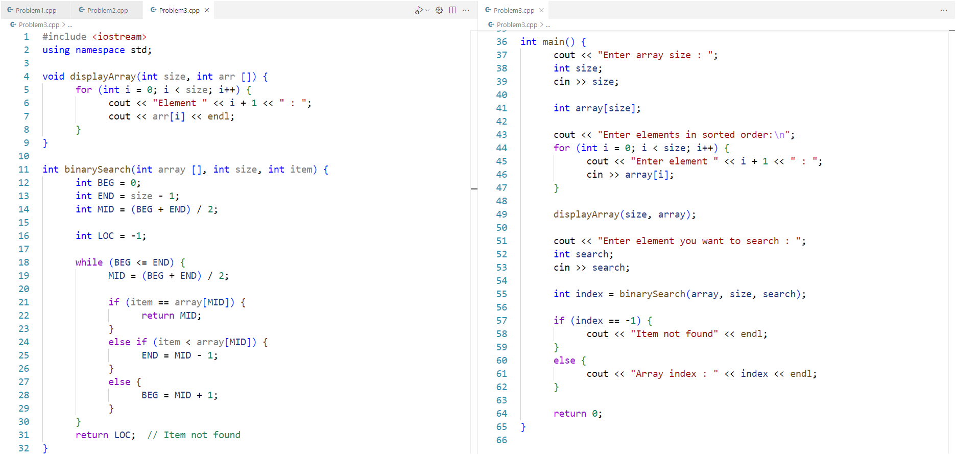Code:

Output:

